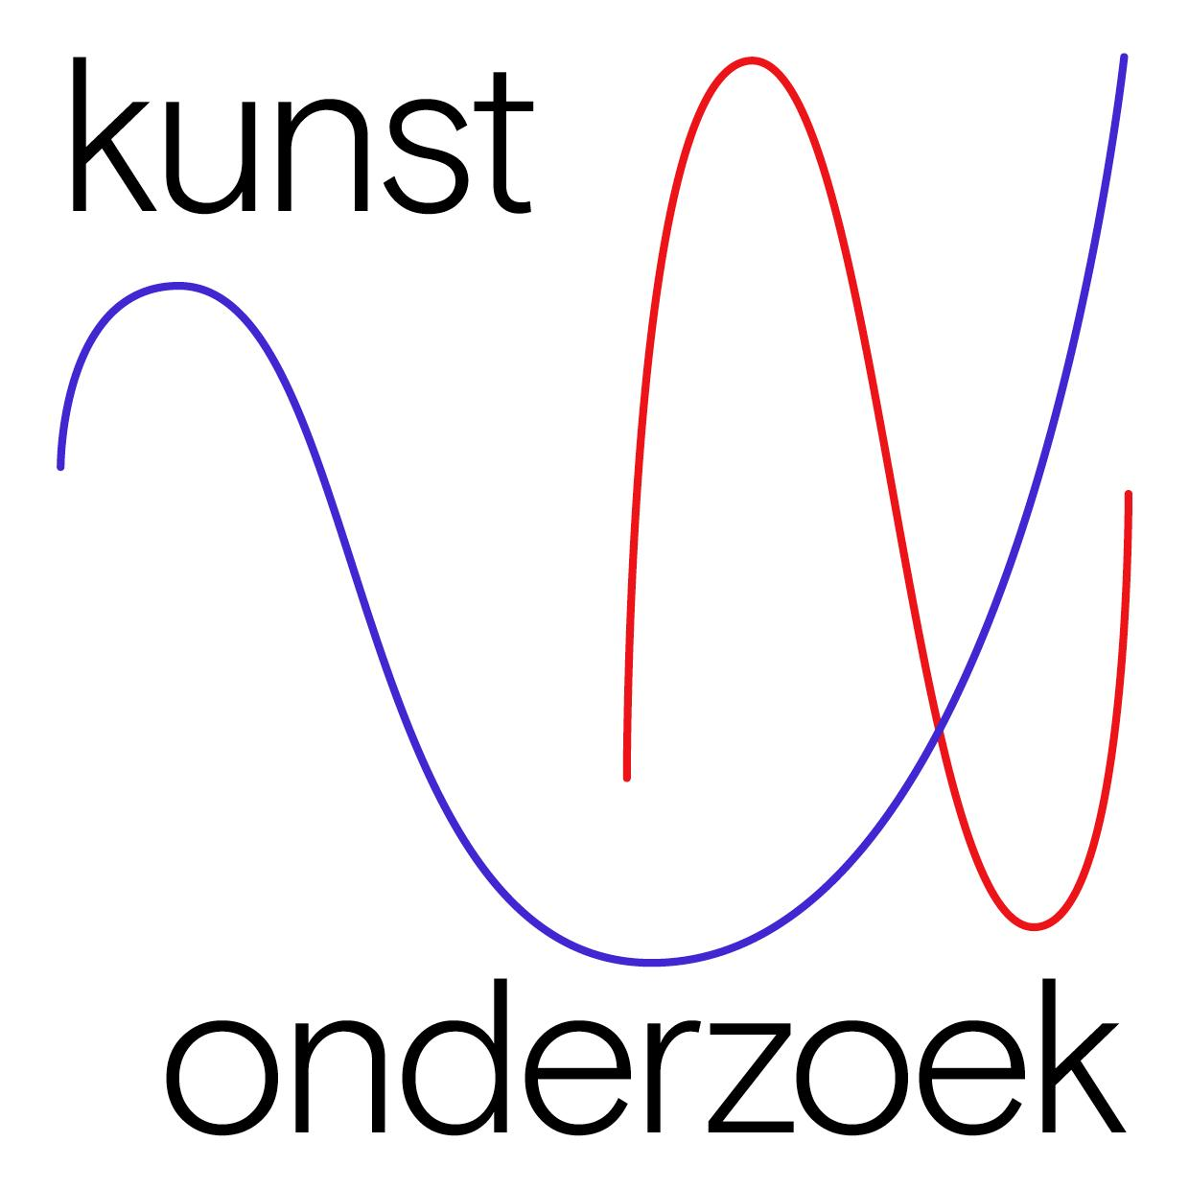
Proposal for contribution at DIS_SEMINAR #2
Name:
Lectoraat/Professorship:
Institution:
Email:
Phonenumber:

YES, the professorship would like to contribute to the exposium with or as:
(multiple options possible)

☐ PRESENTER of a session. Name(s): …
Please fill in the red boxes below.

☐ MODERATOR/DISCUSSION LEADER of a session. Name(s): …

☐ REF-LECTOR of a session. Name(s): …

FOR PRESENTATIONS, please provide the following information:

Description of the presentation/contribution (max. 250 words):

Dissemination form (performance, video, etc):

Question/interaction you want to bring in (concerning form, proces, criteria, etc):

Productional, technical and/or financial conditions:

Other remarks:

Please send this form no later than October 18, 2022 to: kunstenonderzoek@gmail.com

